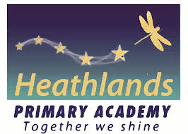
Supporting all children to become confident, fluent readers
At Heathlands, we believe it is paramount that we give your child the best possible start to early reading. We would love our children to have a love for reading. Please aim to read with your child daily and at least 3 times a week (either reading/re-reading their book band book as well as enjoying their Love of Reading book with you). By engaging in regular reading sessions, children will expand their vocabulary and broadening their horizons. Reading regularly also enables pupils to practise essential skills such as phonics, fluency and comprehension.

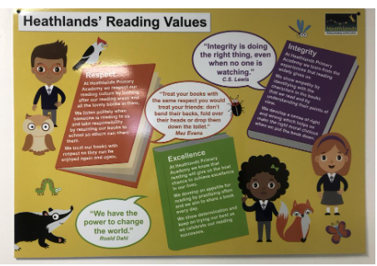
Information for parents & carers
How are books changed?
- Every week, your child will be given specific book band books by their teacher. These books match your child’s developing phonic knowledge.
- Throughout the week, your child will also have the opportunity to choose a library book.
- It is likely that your child will come home with books they have read before. Re-reading for fluency and identifying favourite books for enjoyment is an important part of the reading curriculum and supports learning.
- Children will be read with weekly and the day may vary week to week. Please ensure reading logs and books are in your child’s book bag every day.
What will my child bring home?
- A Little Wandle book band reading book that is individually selected for your child to have complete success in reading. These books are for your child to practise the specific phonic sounds that they have been taught. Once children have moved beyond these sets and have finished phonics, they can select their own book band books. The teachers will choose the colour band.
- A library Reading book. This is a book your child chooses when visiting the library at school and may be one that you share together.

How can I help my child become a fluent reader?
- Repeat reading: once your child has decoded a page, encourage them read it a second or third time to develop fluency. This also helps with comprehension.
- Echo reading: try reading a page first and then your child reads the same page themselves.
Fluency is when children read with expression, use punctuation to help expressions, read smoothly, read at pace and self-correct.
What will happen at school?
- Children will have regular reading opportunities with adults at school
- Children will participate in regular reading lessons to support word reading and comprehension.
- Children will participate in daily phonics and spelling lessons to support reading and writing.
- Classes will have regular story time to encourage a love of books and talk about the children’s favourites.

What will we do at home?
- Read together regularly and at least 3 times a week. Even 5 minutes make a difference.
First Read: Decoding - using phonic knowledge to decode and read words
Second Read: Fluency – the story becomes more familiar. Children have the chance to read again and show less reliance on phonics, reading more words by sight.
Third Read: Fluency and Oral Comprehension - re-reading the book with expression, pace and understanding.
- In Reception, practise the weekly sounds and words that are sent home.
- Re-read books for fluency and talk about events in the text.
- Share other stories, magazines, comics just for fun.
- Please record each read in the reading book and ensure reading logs and books are brought into school every day.
- Remember children can read to anyone not just you!

Top Tips
- Make reading a regular routine, ideally on a 1:1 basis.
- Turn off the TV (and other devices), sit somewhere comfortable and relax.
- Before reading each page, identify words that might be tricky to sound out.
- Have a sound mat nearby to help your child apply their phonics knowledge.
- Sound mats will be sent home with your child.
- If your child is tired or finding it tricky, try sharing the task by reading a page each.
- Try explaining the meaning of a couple of words each time you read together.
- Ask questions about characters and events.
- Praise your child for their efforts.

After 10 reads… | A star reader sticker | 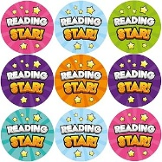
After 25 reads…. | A star reader sticker and bronze certificate | 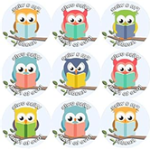 | 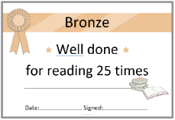
After 50 reads… | A bookmark and silver certificate | 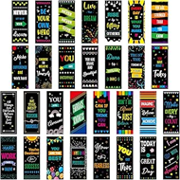 | 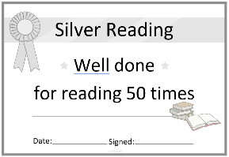
After 75 reads… | A wristband and gold certificate | 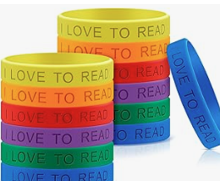 | 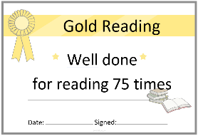
After 100 reads… | A Reading Award Certificate and medal | 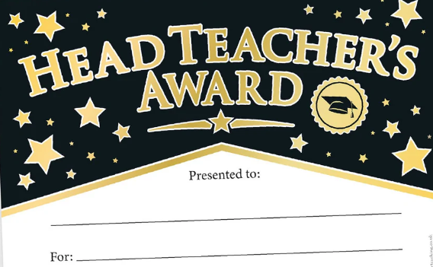 | 
After 150 reads… | Children can choose their favourite book to share with their class. This can be a book form school or one they choose to bring in from home.
After 200 reads… | A badge presented in assembly | 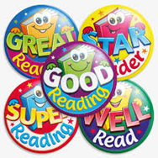 | Parents invited in to the library to share books.
How will regular readers be rewarded?
- At Heathlands, we celebrate the children’s reading efforts at home.
- Reading logs will be checked weekly and adults will keep a record of how many reads your child has completed over the past week. As children achieve a certain number of reads, they will receive a small award to celebrate.
- Reading in school during daily reading sessions will be celebrated with one child from each class being presented with a certificate in assembly.



