To help your child with their learning in maths please try to spend some time each week practising the following skills and concepts.
Try to make it a fun part of your routine such as:
• Counting how long it takes to do something- count in 2s/ 3s/ 5s or 10s
• Look for ways to ask maths questions such as I have £1.20and you have 80p - how much more or less do I have?) Children find how many fewer or how many less much harder than how many more questions)
• Count the values of your change-including silver coins- put in a pot each day and count up at the end of the week.
• Use coins to make amounts- play shops at home/ help when in real shops- practice giving change by counting on or back
• Work out how long a journey or TV programme will last and compare different ones to see how much longer or shorter
• Solve problems such as working out how many packs of cakes will be enough, how many items you can buy for £2.00 or 50p etc
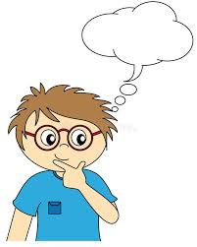
• Help your child practise recall of number facts and times tables (2/5/10)

Here are the key things your child is expected to know BY THE END OF YEAR 2
COUNTING
• Count forwards AND backwards in 1s, 2s,3s, 5s and 10s , crossing the 100 ADDITION & SUBTRACTION
• Learn and use number facts up to 20 e.g. -1 3+4=17 ,1 6+4=20, 12+7=19 etc
• Learn subtraction facts from 20 e.g. 19-15= 4,
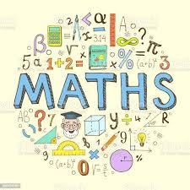
• Add & subtract with 2 digit numbers (e.g. 37 or 59)
• Add 3 single digit numbers e.g. 5+8+9
MULTIPLICATION & DIVISION
• Know and use the 2, 5 and 10 times tables- quick recall
• Know and use the division facts from the 2, 5 and 10 times tables
• Solve problems involving multiplication and division with objects, pictures and mental methods MEASURES & SHAPE
• Tell the time to 5 minutes, quarter to/ past the hour
• Choose and use the correct unit of measurement for length/ mass/ height etc- comparing and ordering the measures
• Recognise symmetry in shapes
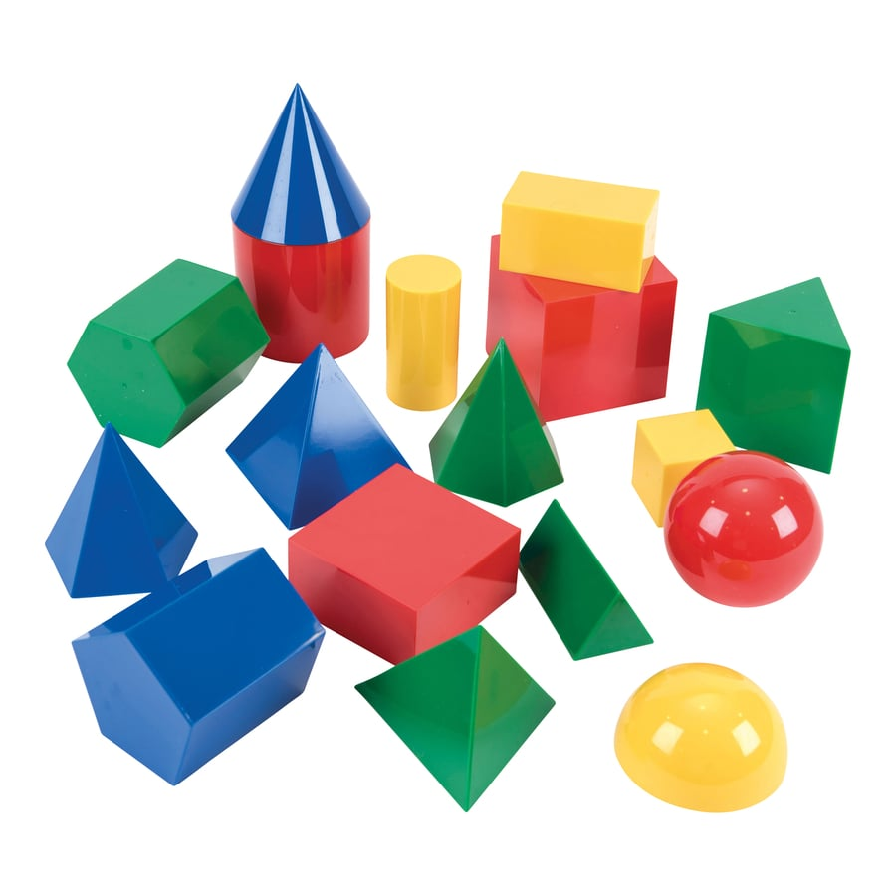
• Recognise halves/ quarters and thirds of lengths or shapes
• Name and describe 2-D and 3-D shapes
• Recognise patterns and sequences including those with right angles quarter turns for example
• Construct and read bar charts and tables including those with measures and times

