Develop their language
– use your home language.
- talk to them, show interest in what they are saying.
- play with words that rhyme e.g. fat, cat, sat, flat, hat- make a silly sentence or rhyme.
- share stories and books with them- use the pictures to encourage them to tell you a story.
- name what you see in the pictures, ask questions- who/ what/ where/ why?
- make up a story using a few props- who/ where/ what doing?

Reading
- read home reading book and talk about the story.
- ask questions.
- practise reading sight words. The children will bring them home.
- read recipes, instructions etc.
- find out about something of interest.
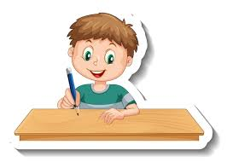
- share books, comics at home.
Writing
-draw a picture and write a story about it.
-write a letter to post -practise spelling sight words.
– put the sight words into sentences.
-practise handwriting- see handwriting sheet the children have brought home.
- write an information leaflet or make a book about something interesting.
Develop their maths skills
- count more than 20 objects
- count up and down from 100, count in 10s, count in 5, 2s, start from numbers other than 0 e.g., 1,6,11,16 or 99,89,79 etc
- practise addition number facts to 20 e.g., 15+5 but also 15+4, 15+3, 15+2, 15+1, 15+0
- practise subtraction from number up to 10 e.g., 20-9, 20-8, 20-7, 19-0, 19-1 etc.
- make up number stories that add/ subtract, multiply and divide e.g. I have 5 cakes, I eat 2. How many do I have now? I have 3 bags of sweet, each bag has 5 sweets. How many altogether? I have 12 biscuits. I share them with my 2 brothers. How many do we have each?
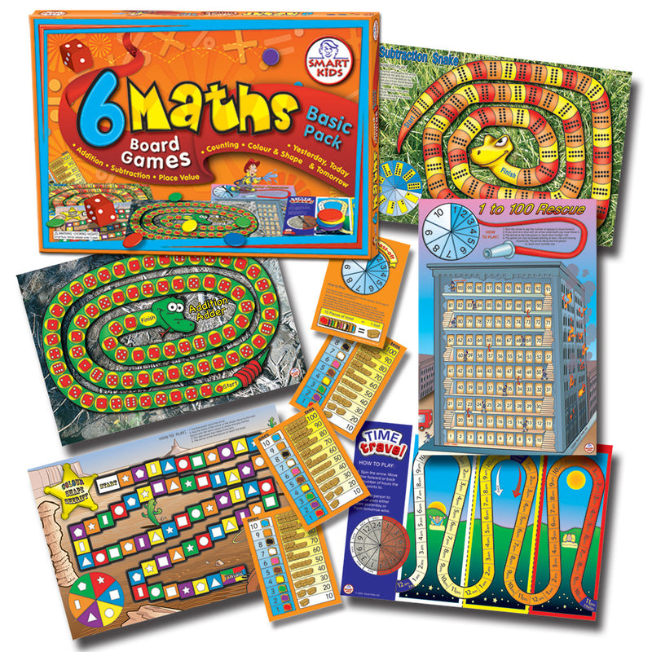
- learn times tables- 2, 5, 10 and then 3.
-play board games such as snakes and ladders
- count coins- play shops
- try to tell the time (lots of repetition here!)
- cook and bake using scales to measure and clocks to measure time to cook.
- see how much time has passed e.g. I started drawing at 3pm and now its half past 3. I have been drawing for 30 minutes…


